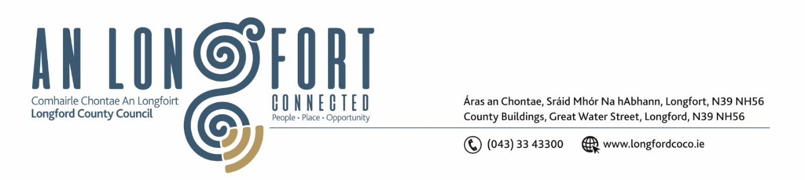

**LONGFORD MUNICIPAL DISTRICT**

***Please note meeting will be held in the Council Chamber, Aras an Chontae and via Microsoft Teams***

**15 May 2024**

**To: Each Member of Longford Municipal District.**

**Dear Member,**

You are requested to attend the Meeting of Longford Municipal District to be held in **the Council Chamber, Aras an Chontae** and **via Microsoft Teams** on **Wednesday, 22 May 2024 at 10am** to transact business, as set out on the agenda hereunder.

**Yours sincerely**,

_______________

**Claire McNabola**

**Meetings Administrator**

**AGENDA**

Prayer before meeting.

**1.** Confirmation of Minutes:

1. Longford Municipal District Meeting held on Wednesday 24 April 2024 – enclosed.
2. Longford Municipal District Committee Meeting held on Wednesday 24 April 2024 – enclosed.

**2.** Matters arising from Minutes.

**3.** Declaration of Interest by Members.

**4.** Management Report – enclosed

**5**. Community Grants (look at declined grants)

**6.** Update on works on Battery Road from Active Travel Team

**7**. Michael Neary Park

**8**. Notice of Motions set our hereunder:

**Councillor Uruemu Adejinmi**

1. I call on Longford County Council to conduct an inspection of footpaths in Ardnacassa Lawns and Midara Gardens and carry out upgrade works on the footpaths as needed.
2. I call on Longford County Council to introduce speed reducing measures in Ardnacassa Lawns and Battery Court Estates and erect signage for safety of children and elderly residents in the areas.